PART I
Total Value: 35 marks

1. Which Venn diagram represents the intersection of sets A, B, and C as the empty set, (A ∩ B ∩ C) = { } ?
- 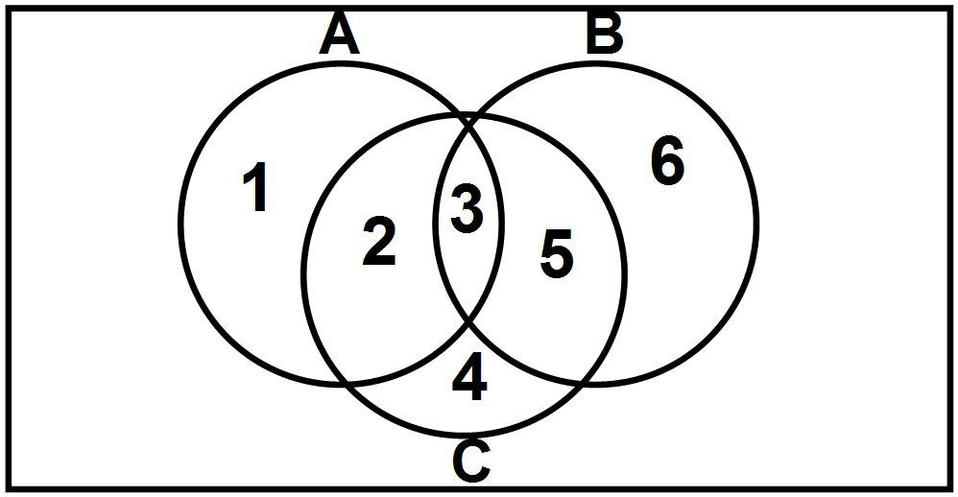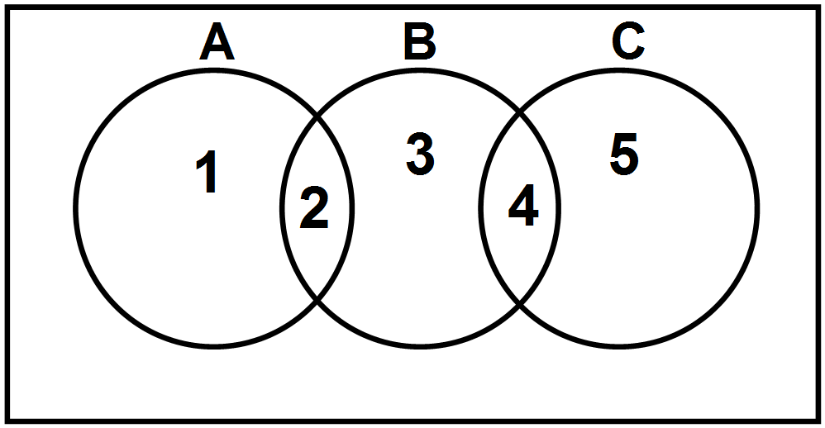 (B)

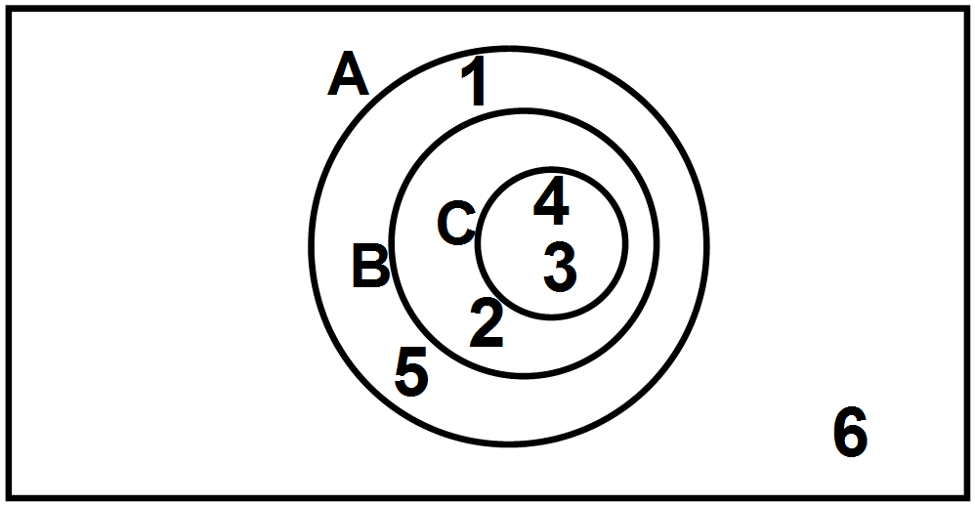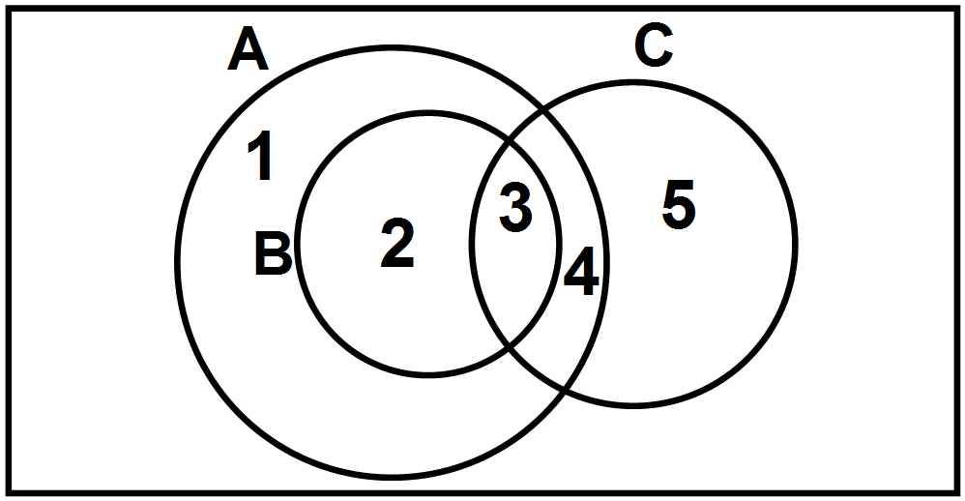(C) (D)

2. Given the following situation:
• the universal set U = {positive integers less than 15}
• X = {4, 5, 6, 7, 8}
• P = {prime numbers of U}
• O = {odd numbers of U}
Which diagram represents the situation?
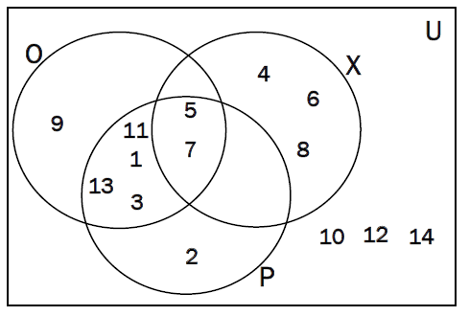
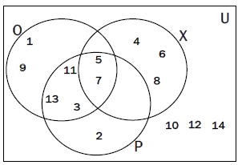
- (B)

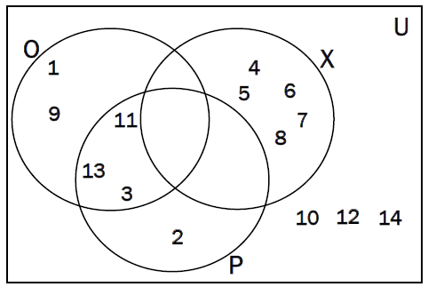
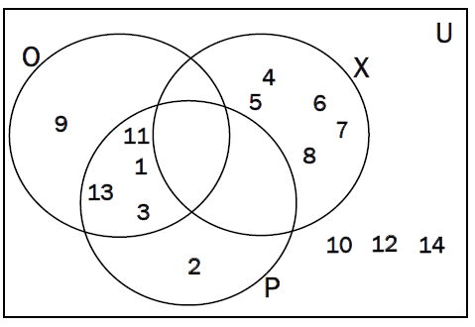
(C) (D)

3. What does the shaded portion of the Venn diagram represent?

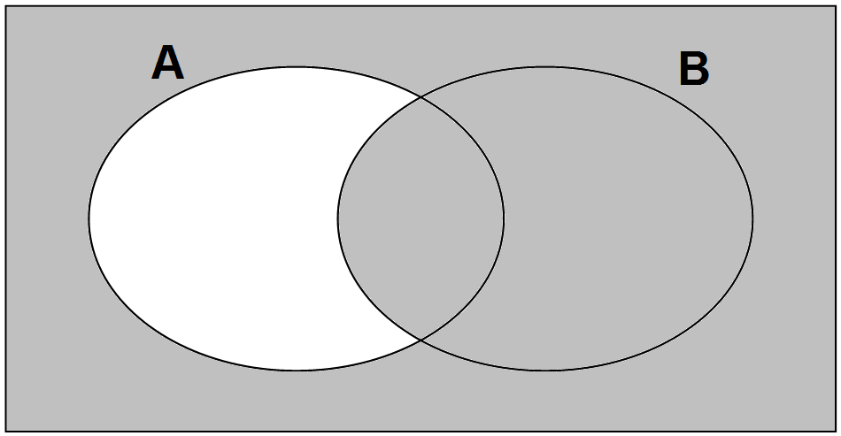

(A) $A\backslash B$ A minus B
(B) $\left(A\backslash B\right)'$ The complement of A minus B
(C) $B\backslash A$ B minus A
(D) $\left(B\backslash A\right)'$ The complement of B minus A
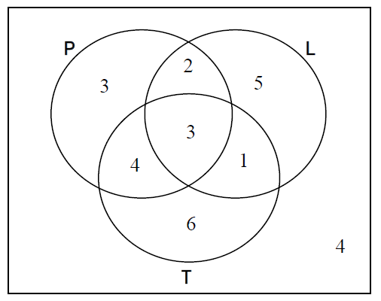
4. The Venn diagram indicates the number of students
in a class owning Internet capable devices (tablet, T;
phone, P; and laptop, L). What is $n\left[{\left(P∩T\right)}^{'} \right]$ ?

(A) 7
(B) 17

(C) 21
(D) 24

5. Which set is equivalent to P = (8, 16, 24, 32, … 800)?

(A) $A=\left(a | a=4x, 2≤x ≤ 200, x ϵ N\right)$
(B) $B=\left(b | b=8x, x ϵ N\right)$
(C) $C=\left(c | c=4x, x ϵ N\right)$
(D) $D=\left(d | d=8x, 1≤x ≤ 100, x ϵ N\right)$

6. Joe was asked to solve this problem:

Yesterday, 10 people had a day pass for Marble Mountain. 5 people skied. 6 people snowboarded and 2 did both. How many did not use their day pass?

Joe’s Solution: (6 + 5 - 2) - 10 = -1

This answer is not possible. Which represents a correct solution to the problem?

(A) 10 - (6 + 5 - 2) = 1
(B) (6 + 5) - 2 = 9
(C) (6 + 5 + 2) - 10 = 3
(D) (5 + 2) + (6 + 2) - 10 = 5

7. When will $n\left(A∪B\right)=n\left(A\right)+n(B)$, the number in the union of A and B be equal to the sum of the number in A and the number in B?
(A) (B)

(C) (D)

- A coach must select a uniform consisting of a pair of shorts and a sweater. Given the selections below, how many variations of uniforms are possible?
Shorts Colour  Black  White  Red  Purple | Sweater Colour  Orange  Yellow  Blue

- 7 (B) 12 (C) 21 (D) 42
- Consider the word EXAM. In how many different ways can the letters be arranged?
- 1 (B) 4 (C) 10 (D) 24
- Evaluate : $\frac{83!}{81!}$
- 2 (B) 165 (C) 6806 (D) 551286
- Simplify: $\frac{\left(n-4\right)!}{\left(n-6\right)!}$

- $\frac{1}{n^{2}+20}$ (B) $\frac{1}{n^{2}-9n+20}$ (C) $n^{2}+20$ (D) $n^{2}-9n+20$

- In how many ways can gold, silver, and bronze medals be awarded if there are 7 people in a swimming race?

- ${}_{7}C_{3}$
- ${}_{7}P_{3}$
- $\frac{7!}{3!}$
- $7!$

- In how many ways can the letters in the word S E T T L E R S be arranged?
- 5040 (B) 10080 (C) 40320 (D) 80640
- Using the grid below, you must travel from A to B by only heading East (E) or South (S). One example of a route is represented by 8 moves East followed by 4 moves south (EEEEEEEESSSS). Under these rules, which represents the total number of possible routes that can be taken to get from A to B?
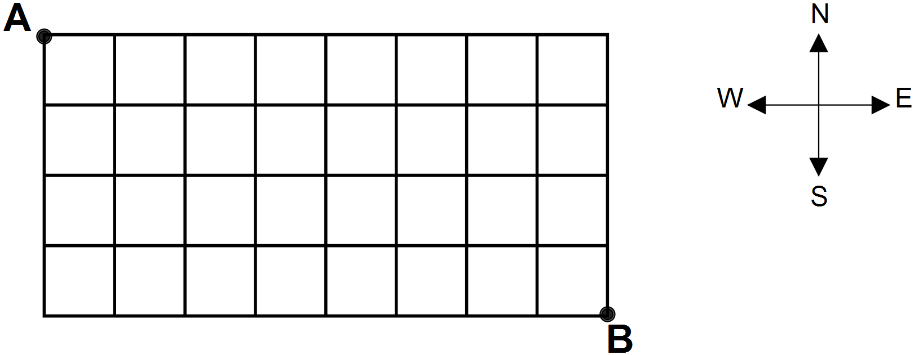
- 495 (B) 285120 (C) 967680 (D) 479001600
- In how many ways can a 4 topping pizza be made from 9 different toppings?
- ${}_{4}C_{9}$
- ${}_{4}P_{9}$
- ${}_{9}C_{4}$
- ${}_{9}P_{4}$

- A committee of two people will be chosen from 4 females and 3 males. How many committees are possible with at least one male?
- 12 (B) 15 (C) 21 (D) 36
- A softball team consists of 10 players. The players need to be placed in 3 separate hotel rooms. One room can accommodate 4 players and the other two can take 3 players each. In how many ways can the players be placed in the rooms?
- ${}_{10}C_{4}×{}_{6}C_{3}×{}_{3}C_{3}$
- ${}_{10}C_{4}×{}_{10}C_{3}×{}_{10}C_{3}$
- ${}_{10}P_{4}×{}_{6}P_{3}×{}_{3}P_{3}$
- ${}_{10}P_{4}×{}_{10}P_{3}×{}_{10}P_{3}$

18. Environment Canada says the probability of precipitation for tomorrow in Goose Bay is 60%. What are the odds for precipitation tomorrow in Goose Bay?

(A) $2:5$ (B) $2:3$ (C) $3:2$ (D) $5:2$

19. A fair coin is tossed twice. Which expression indicates the probability of “getting two heads”?

(A) $\frac{1}{4}+\frac{1}{4}$ (B) $\frac{1}{4}×\frac{1}{4}$ (C) $\frac{1}{2}+\frac{1}{2}$ (D) $\frac{1}{2}×\frac{1}{2}$

20. There are 30 students in a class. 16 students browse the Internet and 10 students use email. 6 students do both. What is the probability that a randomly selected student in the class browses the Internet or uses email?

(A) $\frac{2}{3}$ (B) $\frac{11}{15}$ (C) $\frac{4}{5}$ (D) $\frac{13}{15}$

21. In a survey, 42% of households contacted owned a laptop, 13% owned a curved 3-D television, and 53% owned neither. What is the probability that a randomly selected household will own both?

(A) 4% (B) 5% (C) 7% (D) 8%

22. You are on a game show and are given 5 digits to arrange in the proper order to form the price of a car. If you are correct, you win the car. What is the probability of winning if you know the first digit for sure and guess at the others?

(A) $\frac{1}{120}$ (B) $\frac{1}{24}$ (C) $\frac{1}{15}$ (D) $\frac{1}{10}$

23. Tyler and Tesia each randomly choose in their head (mentally) an integer from 1 to 10 (inclusive). They then write it out on a piece of paper. What is the probability that Tyler’s number is even and Tesia’s number is divisible by 3?

(A) 0.10 (B) 0.15 (C) 0.70 (D) 0.80

24. A pack of 52 cards consists of four different coloured sets numbered 1 to 13 as shown below. If you randomly pick 5 cards from the pack, which expression indicates the probability that you have at most one 13?

 | Card Colour | Cards
 | Red
 | Blue
 | Green
 | Yellow

(A) $\frac{\left({}_{4}C_{0}×{}_{48}C_{5}\right)+\left({}_{4}C_{1}×{}_{48}C_{4}\right)}{{}_{4}C_{1}×{}_{48}C_{4}}$ (B) $\frac{\left({}_{13}C_{0}×{}_{39}C_{5}\right)+\left({}_{13}C_{1}×{}_{39}C_{4}\right)}{{}_{4}C_{1}×{}_{48}C_{4}}$

(C) $\frac{\left({}_{4}C_{0}×{}_{48}C_{5}\right)+\left({}_{4}C_{1}×{}_{48}C_{4}\right)}{{}_{52}C_{5}}$ (D) $\frac{\left({}_{13}C_{0}×{}_{39}C_{5}\right)+\left({}_{13}C_{1}×{}_{39}C_{4}\right)}{{}_{52}C_{5}}$

25. A company has two factories that make computer chips. 70% of the chips come from factory 1 and 30% of the chips come from factory 2. In factory 1, 25% of the chips are known to be defective. In factory 2, 10% of the chips are known to be defective. If a defective chip is discovered, what is probability that it came from factory 1 to the nearest tenth of a percent?

(A) 14.6 (B) 20.5 (C) 79.5 (D) 85.4

26. What are the non-permissible values for the rational expression $\frac{x(x-1)}{2x(3-x)(3x+1)}$ ?

(A) $\left\{-\frac{1}{3}, 0, 1, 3\right\}$ (B) $\left\{-\frac{1}{3}, 0, 3\right\}$ (C) $\left\{-\frac{1}{3}, 3\right\}$ (D) $\left\{0, 1\right\}$

27. Which rational expression has non-permissible values of 0 and $-3$ ?

(A) $\frac{5x}{x(x+3)}$ (B) $\frac{5}{x(x-3)}$ (C) $\frac{x(x+3)}{5}$ (D) $\frac{x(x-3)}{5}$

28. Which expression is equivalent to $\frac{x+10}{x+6} , x≠-6$ ?

(A) $\frac{x+5}{x+3}$ (B) $\frac{2x^{2}+20x}{{2x}^{2}+12x}$ (C) $\frac{2x+20}{2x+12}$ (D) $\frac{2x+10}{2x+6}$

29. Simplify to lowest terms: $\frac{2x+8}{{2x}^{2}-32}$ ,$x≠$ $-4, 4$

(A) $\frac{1}{x+4}$ (B) $\frac{1}{x-4}$ (C) $\frac{x+4}{x^{2}-16}$ (D) $\frac{x+8}{x^{2}-32}$

30. Simplify: $\frac{{5x}^{2}}{5x^{2}-25x} ,$ $x≠0, 5$

(A) $-25x$ (B) $-\frac{1}{25x}$ (C) $\frac{1}{x-5}$ (D) $\frac{x}{x-5}$

31. Simplify to lowest terms: $\frac{x^{2}}{x-6}∙\frac{5x-30}{2x} ,$ $x≠0, 6$

(A) $\frac{5x}{2}$ (B) $\frac{5x^{2}}{2x}$ (C) $\frac{5x(x-30)}{2(x-6)}$ (D) $\frac{5x(x+6)}{2(x-6)}$

32. Simplify: $\frac{3x}{5}÷\frac{2x^{3}}{10} ,$ $x≠0$

(A) $\frac{3x^{4}}{25}$ (B) $\frac{3x^{3}}{25}$ (C) $\frac{x^{2}}{3}$ (D) $\frac{3}{x^{2}}$

33. Simplify: $\frac{4-3x}{x+3}+\frac{2x+3}{x+3} ,$ $x≠-3$

(A) $\frac{7+5x}{x+3}$ (B) $\frac{7-x}{x+3}$ (C) $\frac{7+5x}{2x+3}$ (D) $\frac{7-x}{2x+6}$

34. Simplify: $\frac{-4x}{x+5}-\frac{2x}{2x+10} ,$ $x≠-5$

(A) $\frac{-6x}{2\left(x+5\right)}$ (B) $\frac{-2x}{2\left(x+5\right)}$ (C) $\frac{-5x}{x+5}$ (D) $\frac{-3x}{x+5}$

35. Peter can plant a vegetable garden in 8 hours. If Susan helps him, they can plant the garden together in 6 hours. Which equation can be used to find the time it takes Susan to plant the garden alone?

(A) $\frac{1}{8}+\frac{1}{x}=$ $6$ (B) $\frac{1}{6}+\frac{1}{x}=$ $8$

(C) $\frac{1}{8}+\frac{1}{x}=\frac{1}{6}$ (D) $\frac{1}{6}+\frac{1}{x}=\frac{1}{8}$

PART II - Total Value: 35 marks

Answer ALL items in the space provided. Show ALL workings.

Value
3 36(a). Students were surveyed on what beverage(s) they have ordered at the
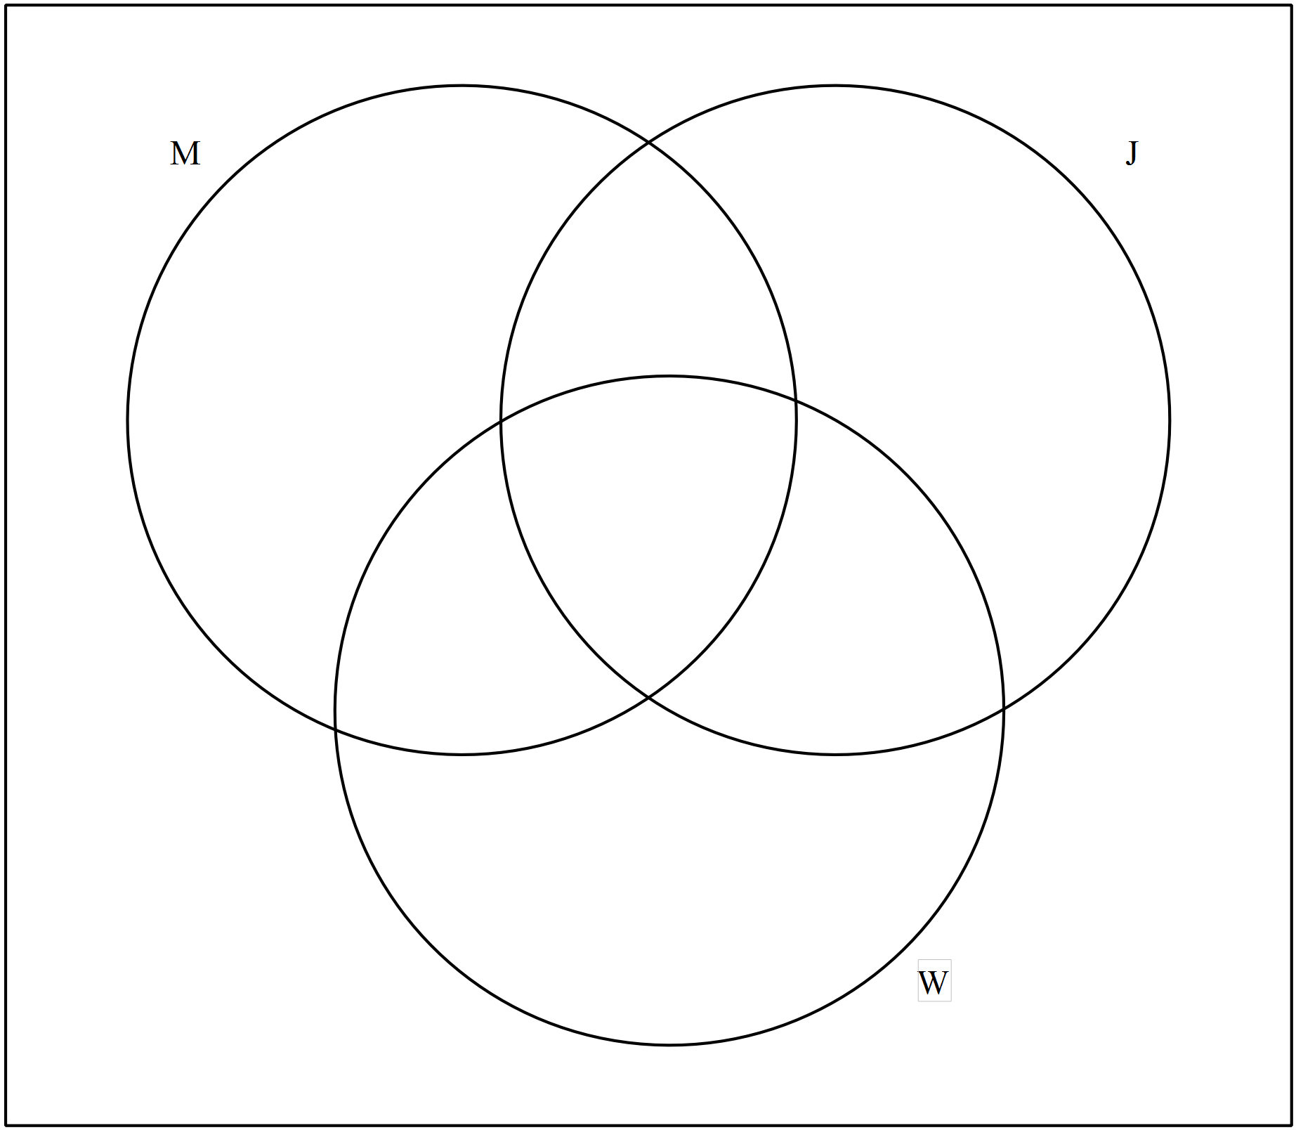 cafeteria.
- 130 ordered milk
- 140 ordered juice
- 170 ordered water
- 40 had ordered juice and milk
- 70 had ordered juice and water
- 50 had ordered milk and water
- 30 had ordered all three
- 30 had not ordered any beverage

Draw a Venn diagram to illustrate this information
and use it to determine how many students were surveyed.

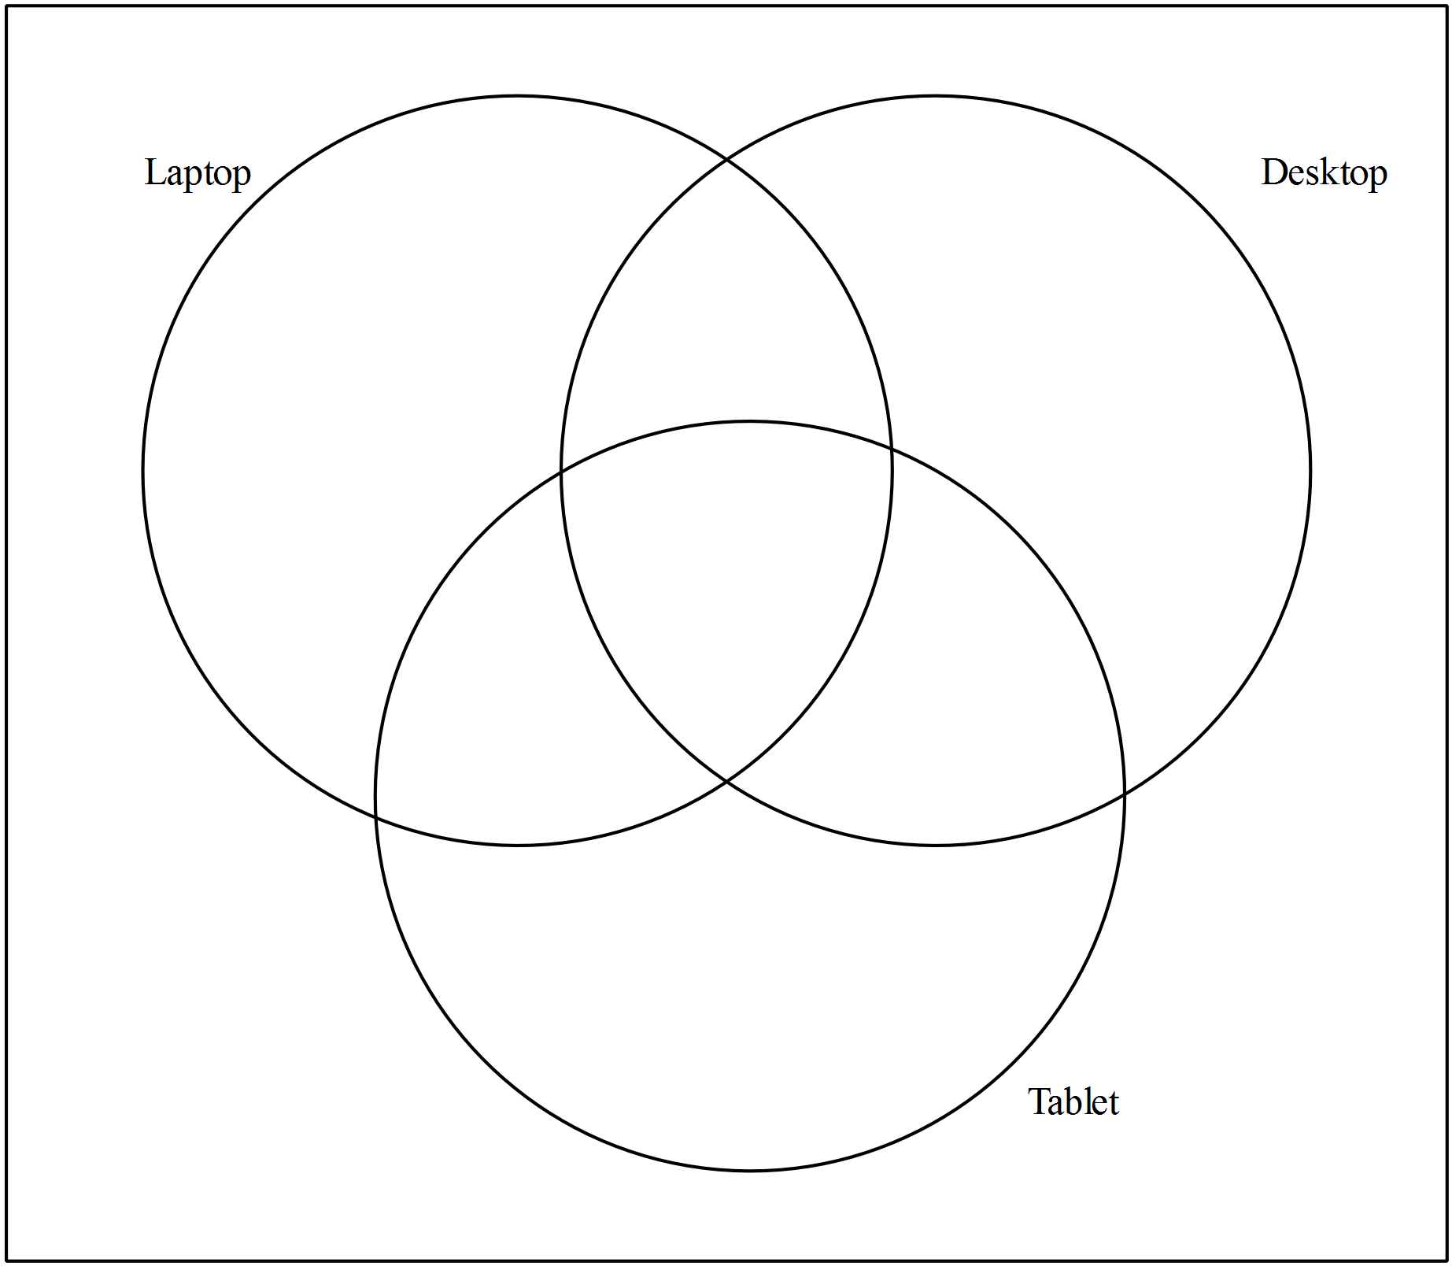3 36(b). In a group of 35 people:

- 18 people own a laptop computer
- 19 people own a desktop computer
- 17 people own a tablet computer
- 5 people own a laptop and a desktop but not a tablet
- 6 people own a desktop and a tablet but not a laptop
- 3 people own all three types of computers
- 4 people do not own either type of computer
Determine the number of people who own a laptop and a tablet, but not a desktop.

2 37(a). In how many ways can a teacher arrange 9 students in a line if Alice, Bob, and Carol must be seated together?

2 37(b). In Newfoundland and Labrador a license plate consists of a letter-letter-letter-digit-digit-digit arrangement such as CRT 123.
- How many arrangements are possible if a license plate must start with C and end in 3 when repetition is allowed?

- How many arrangements are possible if a license plate must start with C and end in 3 when repetition is not allowed?

3 37(c). Algebraically solve for n: ${}_{n}C_{2}=120$

3 37(d). Given the digits 1, 2, 3, 4, and 5 how many two or three digit even numbers can be made if repetition is not allowed?

3 38(a). Nine horses are entered in a race and each one is equally likely to win. To the
nearest percent, determine the probability that one horse, Mr. Mal, will not finish in the top three. Show your workings.

3 38(b). There are 6 blue marbles, 3 red marbles, and 1 green marble in a bag. If you reach in and randomly select 2 marbles from the bag, what are the odds of them both being blue? Show your workings.

3 38(c). A committee of 4 people is chosen at random from 5 married couples. What is the
probability that the committee contains no married couples? Show your workings.

39(a). Karen simplified an expression as follows:

$$\frac{2x+8}{x^{2}-16}-\frac{x}{2x-8}$$

$=\frac{x+4}{x^{2}-16}-\frac{x}{x-4}$ Step 1
$=\frac{x+4}{\left(x+4\right)\left(x-4\right)}-\frac{x}{x-4}$ Step 2
$=\frac{1}{x-4}-\frac{x}{x-4}$ Step 3
$=\frac{1-x}{x-4}$ Step 4

1 (i) Identify the step in which the error occurred and explain the mistake.

3 (ii) Correct the error and simplify.

2 39(b). Simplify: , $x≠-6, -3, 3, 6$

4 39(c). A school volleyball team and its chaperones are going to a tournament out of the province that has a total cost of $7200. The cost of the trip is to be divided amongst everyone going. At the last minute, two people get sick and cannot attend, increasing the cost per person by $40. If $x$ represents the number of people travelling and the situation is modelled by
, algebraically determine the number of people who originally planned to attend the tournament.

